5.2 MORE PRACTICE WITH THE VERNIER MICROMETER
Give your answer to the nearest 0.0001 in.
Directions: Take three pennies, and with the vernier micrometer, measure the thickness of each penny, and write the results in the spaces below – when measuring the pennies, put the spindle on the same place, to the right of the Lincoln Memorial, on the edge.
Penny No. 1: _____________ What year is the penny? _____________
Penny No. 2: _____________ What year is the penny? _____________
Penny No. 3: _____________ What year is the penny? _____________
Now find the average (Add the three measurements and divide by three).
The average thickness of a penny is: _____________
******************************************************************************
Get your steel tool bit.
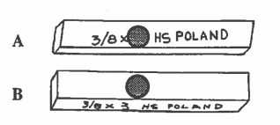Now measure the width of the steel tool bit; measure the width on both surfaces to see if it is perfectly square. Place the spindle on the side with the printing, then measure it with the spindle on the next side over. Write down the two widths and see if they are exactly alike.
The width of A = _____________
The width of B = _____________
Is the steel tool bit perfectly square? i.e. were the two measurements exactly alike?

